6. CONVOLUTION AND SAMPLING TECHNIQUES

Experiment 6.1
Convolution of Continuous Time Signals
Aim:
To perform the convolution of two continuous-time signals using MATLAB. The Aim is to
understand the concept of convolution as a mathematical operation that combines two signals to produce a third signal, representing the amount of overlap between the two as one signal is shifted over the other.
Program:
% Convolution of Continuous-Time Signals
clc;
clear;
close all
% Time axis
t = 0:0.01:5;
% Input signals
x1 = exp(-t); % Exponential signal
x2 = ones(size(t)); % Unit step signal
% Convolution
y = conv(x1,x2)*0.01;
% Time axis for output
t_conv = 0:0.01:(length(y)-1)*0.01;
% Plotting
figure;
subplot(3,1,1);
plot(t,x1,'LineWidth',2);
grid on;
title('Signal x_1(t)=e^{-t}');
xlabel('Time (s)');
ylabel('Amplitude');
subplot(3,1,2);
plot(t,x2,'LineWidth',2);
grid on;
title('Signal x_2(t)=u(t)');
xlabel('Time (s)');
ylabel('Amplitude');
subplot(3,1,3);
plot(t_conv,y,'LineWidth',2);
grid on;
title('Convolution Output y(t)');
xlabel('Time (s)');
ylabel('Amplitude');

Output Waveform:
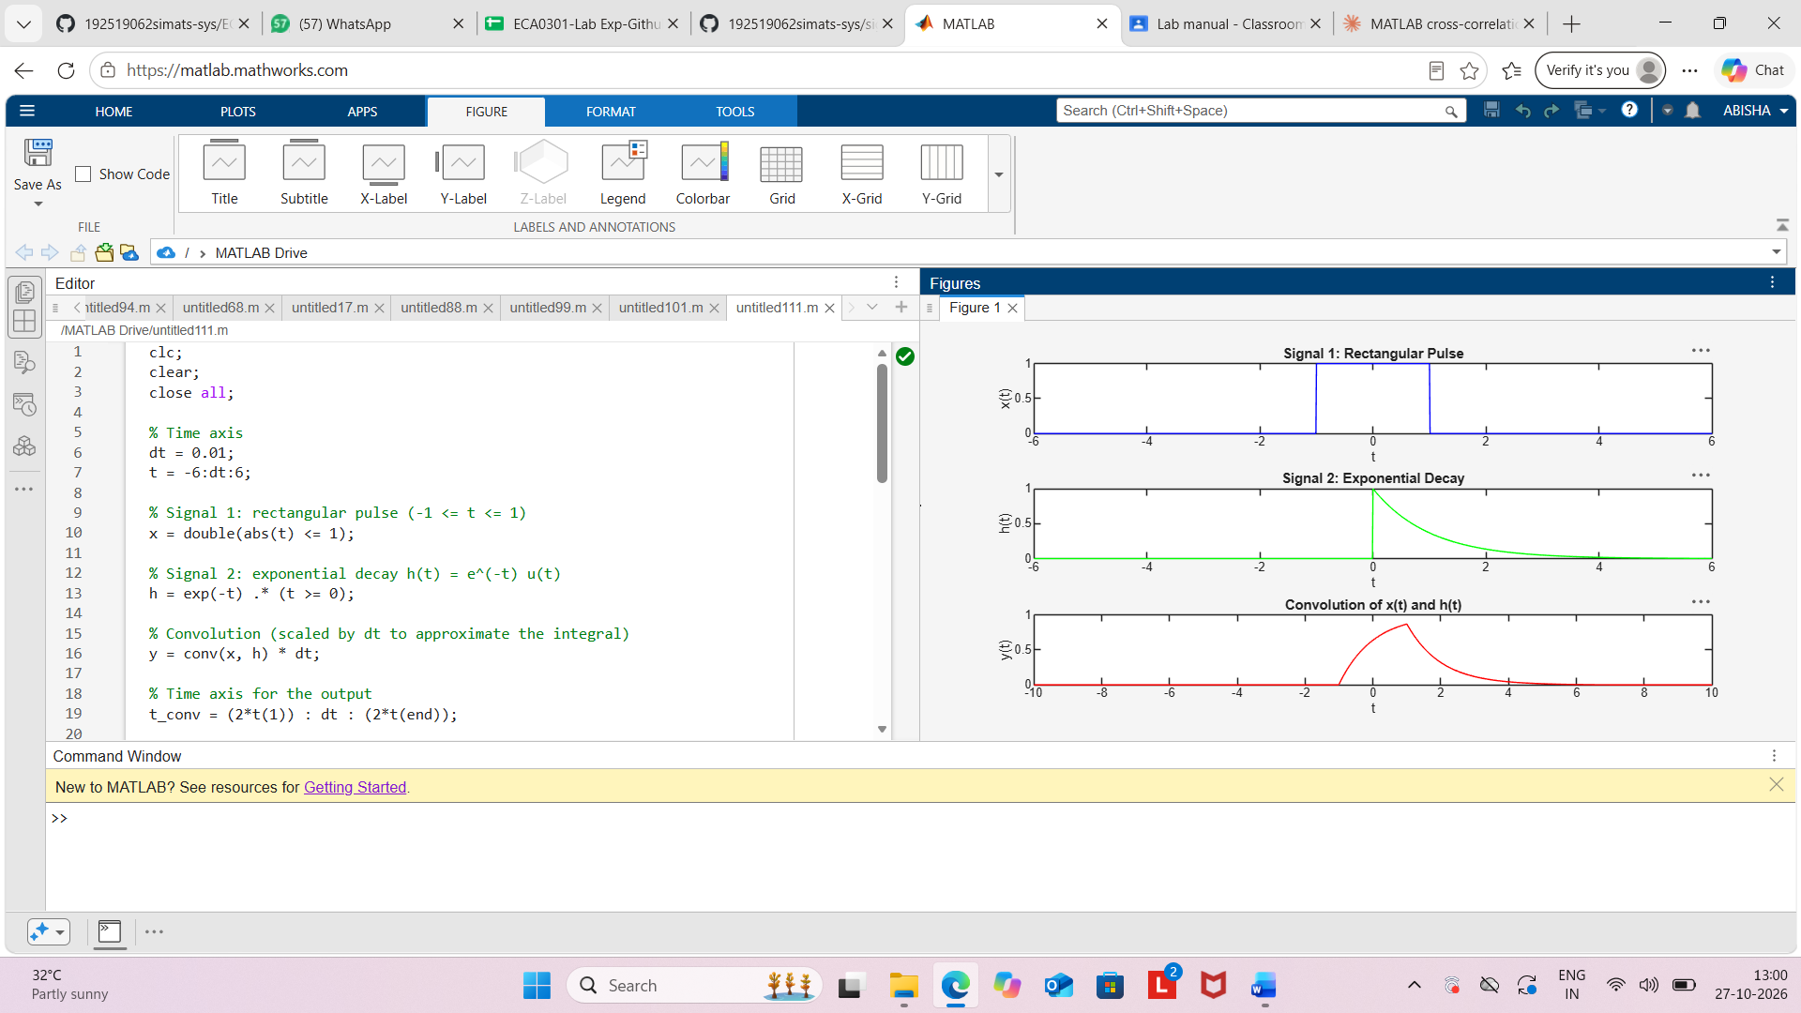
Result:
The convolution of the continuous-time signals x1(t)=e−tu(t) and x2(t)=u(t) was performed
successfully using MATLAB. The output signal y(t)=1−e−t was obtained and plotted,
demonstrating the convolution operation for continuous-time systems.

